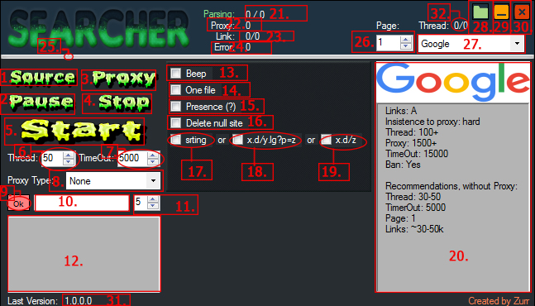
1-5 operation buttons  1. Database load button.  2. Pause button.  3. Proxy load button.  4. Stop button  5. Button to start | 6. Select Number of threads, min. 1, max 600.  7. Select the connection timeout,  min. 1000 ms, max 25000 ms  8. Select a proxy type:  None,HTTP,Sock4,Socks5 | 9. Confirmation button proxy link.  10. Field for link.  11. Update Time proxy(minutes)  12. Field information output to the user.
13-14 program settings  13. Beep at the end of work.  14. If Checked: Creates one file.    If UnChecked: Creates a file depending of type of the selected search engine    15. Save links only with the presence of "?"  16. If checked - does not save link  "http://site.com/", only "http://site.com/aaa",  if unchecked save both options. | 17-19 Delete dublicat  17. Delete duplicate string  input:  "http://site.com/sfs/fsf"  "http://site.com/sfs/fsf"  saves: one result  18. Delete duplicate "="  input:  "http://site.com/sfs=1"  "http://site.com/sfs=2"  "http://site.com/sfs/pr=2"  saves:  "http://site.com/sfs=1"  "http://site.com/sfs/pr=2"  if there is no "=" works as a "string" mode  19. Remove the same sites  input:  "http://site.com/sfs=1"  "http://site.com/sfs=2"  "http://site.com/sfs/par=2"  saves:  "http://site.com/sfs=1"
20. Field, information for the user about Search Engines.
21-24 counters  21. Pars the counter, format:  Completed/All  22. Counter Proxy.  23. The reference count, format:  All collected/Saved. Activated configuration 15-19  24. Connection errors counter. | 25. Progress Bar.  26. Pages parse.  27. Select search engine.
28-30 form buttons  28. Open the folder with the result.  29. Close to tray.  30. Close program. | 31. Last version.  32.Threads, format:  work/all

